6.6 Inferences about regression parameters (Section
6.5 will be done after 6.6)

In Section 5.13, the covariance matrix of b was introduced. In multiple regression, the covariance matrix is the same, but the matrix is larger to account for the additional b_{k}’s.

The covariance matrix of b:
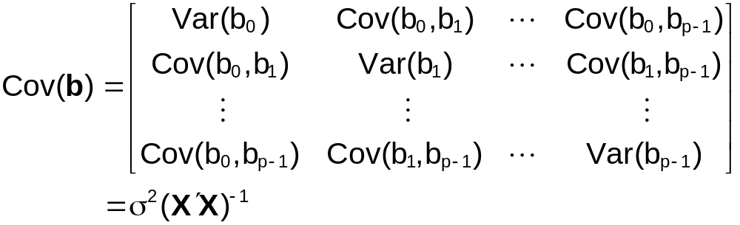

The estimated covariance matrix of b:
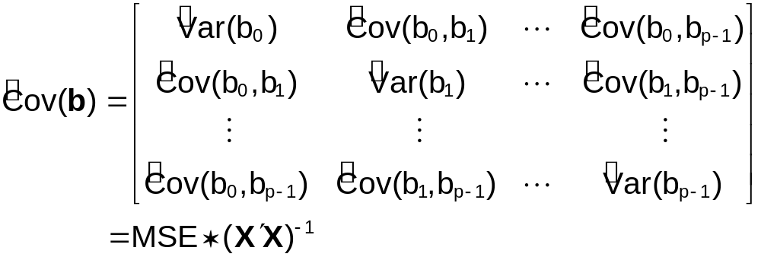

To determine if the k^{th} predictor variable is helpful in predicting the response variable, a t-test for β_{k}=0 can be conducted.

t-test for β_{k} in
E(Y)=β₀ + β₁X₁ +…+ β_{k}X_{k} +…+ β_{p-1}X_{p-1}

- State H₀ and H_{a}
H₀: β_{k}=0
H_{a}: β_{k}≠0
- Test statistic: 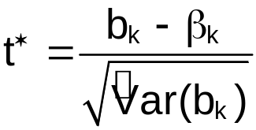
- Critical value: ± t(1-α/2; n-p)
- Reject or don’t reject H₀
- Conclusions

Note: Also can use a p-value for the test

Example: NBA guard example (nba_example.R)

The sample regression model is:

 = -0.4022 + 0.004033∗MPG + 0.003586∗Height +
0.0005883∗FTP

Is player height linearly related to PPM given MPG and FTP are in the model? Use α=0.05 for the hypothesis test.

i.e. Should height be used as a linear term in the model (with MPG and FTP) to estimate PPM?

Part of the R code and output:

> mod.fit<-lm(formula = PPM ~ MPG + height + FTP, data =
nba)
> sum.fit<-summary(mod.fit)
> sum.fit$coefficients
Estimate Std. Error t value Pr(>|t|)
(Intercept) -0.4021933208 0.301014824 -1.3361246 0.1845111648
MPG 0.0040331041 0.001153043 3.4977918 0.0006989877
height 0.0035858278 0.001481248 2.4208156 0.0172708941
FTP 0.0005883381 0.001240881 0.4741292 0.6364311575

Hypothesis test for β_{Height} in
E(PPM)=β₀ + β_{MPG}∗MPG + β_{Height}∗Height + β_{FTP}∗FTP

1) H₀: β_{Height}=0
H_{a}: β_{Height}≠0
- Test statistic
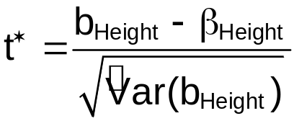=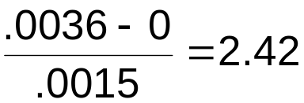
- ±t(1-α/2; n-p) = ± t(0.975, 101) = 1.9837

> qt(p = 1-0.05/2, df = mod.fit$df.residual)
[1] 1.983731

- Since 2.42>1.9837, reject H₀.
- There is sufficient evidence to prove that height is linearly related to PPM given MPG and FTP are in the model (i.e., Height should be used in the model to estimate PPM.)

Notes:
- Since MPG has a p-value = 0.0007 < 0.05 = α, MPG should also be used in the model.
- Since FTP has a p-value = 0.6364 > 0.05 = α, there is not sufficient evidence to prove that FTP is useful in estimating PPM (given MPG and height are already in the model). FTP should be considered for removal from the model (more on this later in Chapter 9).
- A relationship may still exist between PPM and FTP because:
  - A type II error may have been committed.
  - A more complex relationship may exist between PPM and FTP other than the “straight line” hypothesis considered. For example, maybe the correct model is

E(PPM)=β₀ + β_{MPG}∗MPG + β_{Height}∗Height + β_{FTP1}∗FTP + β_{FTP2}∗FTP².

- A Bonferroni adjustment could be used as well to control the family type I error rate. One could use α/g = 0.05/3 = 0.0167 to determine significance.

6.5 Analysis of variance results

ANOVA Table
Source of Variation | SS | df | MS | F
Regression | SSR =  | p-1 | MSR = SSR/(p-1) | F* = MSR/MSE
Error | SSE= | n-p | MSE = SSE/(n-p)
Total | SSTO =  | n-1

Notes:
- SSR has p-1 degrees of freedom. Before with 1 predictor variable, there was only 1 degree of freedom.
- SSE has n-p degrees of freedom. Before with 1 predictor variable, there were n-2 degrees of freedom.
- The F* statistic tests

H₀:β₁=β₂=…=β_{p-1}=0
H_{a}:At least one β≠0

F*~F(p-1, n-p)

Reject H₀ if F*>F(1-α, p-1, n-p)

Example: NBA guard example (nba_example.R)

ANOVA Table

> anova.fit<-anova(mod.fit)
> anova.fit
Analysis of Variance Table

Response: PPM
Df Sum Sq Mean Sq F value Pr(>F)
MPG 1 0.18002 0.18002 15.8265 0.0001308 ***
height 1 0.06530 0.06530 5.7406 0.0184180 *
FTP 1 0.00256 0.00256 0.2248 0.6364312
Residuals 101 1.14884 0.01137
---
Signif. codes: 0 '***' 0.001 '**' 0.01 '*' 0.05 '.' 0.1 ' ' 1
> names(anova.fit)
[1] "Df" "Sum Sq" "Mean Sq" "F value" "Pr(>F)"
> sum(anova.fit$"Sum Sq"[1:3]) #SSR
[1] 0.247875

Notice that R does not directly give the ANOVA table as shown on the previous page. There are rows for MPG, height, and FTP. This is just separating out the “Regression” row of the table. As shown above, SSR = 0.2479. More on how R separates out the sums of squares will be given in Chapter 7.

Determine if the model:

= -0.4022 + 0.004033∗MPG + 0.003586∗Height +
0.0005883∗FTP

is useful for estimating PPM. Use α=0.05 in the hypothesis test.

R code and output:

> mod.fit<-lm(formula = PPM ~ MPG + height + FTP, data =
nba)
> sum.fit<-summary(mod.fit)
> sum.fit

Call:
lm(formula = PPM ~ MPG + height + FTP, data = nba)

Residuals:
Min 1Q Median 3Q Max
-0.21345 -0.06595 -0.01632 0.05298 0.40052

Coefficients:
Estimate Std. Error t value Pr(>|t|)
(Intercept) -0.4021933 0.3010148 -1.336 0.184511
MPG 0.0040331 0.0011530 3.498 0.000699 ***
height 0.0035858 0.0014812 2.421 0.017271 *
FTP 0.0005883 0.0012409 0.474 0.636431
---
Signif. codes: 0 '***' 0.001 '**' 0.01 '*' 0.05 '.' 0.1 ' ' 1

Residual standard error: 0.1067 on 101 degrees of freedom
Multiple R-Squared: 0.1775, Adjusted R-squared: 0.153
F-statistic: 7.264 on 3 and 101 DF, p-value: 0.0001842

> sum.fit$fstatistic
value numdf dendf
7.263975 3.000000 101.000000

> qf(p = 1-alpha, df1 = sum.fit$fstatistic[2],
df2 = sum.fit$fstatistic[3])
[1] 2.694618
> 1-pf(q = sum.fit$fstatistic[1], df1 =
sum.fit$fstatistic[2], df2 = sum.fit$fstatistic[3])
0.0001842469

1) H₀: β_{MPG}=β_{Height}=β_{FTP}=0 vs. H_{a}: At least one β≠0
2) Test statistic: F* = 7.26 (from previous R
output)
3) Critical value: F(1-α, p-1, n-p) = F(0.95, 3, 101) =
2.6946
4)
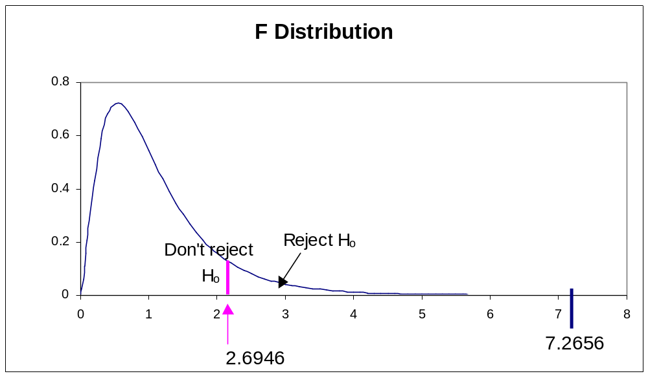
Since 7.2656 > 2.6946, reject H₀.

5) The model (using MPG, Height, and FTP) is useful for estimating PPM.

The p-value = 0.0002 < 0.05 = α so the same conclusion would be reach as with using the test statistic.

This result should seem reasonable. The 3 previous hypothesis tests (t-tests) for each predictor variable concluded that 2 of the variables (at least) were useful in estimating PPM (Section 6.6).

KNN call this a “F test for regression relation”. Others may call this an “overall F test”.

Question:

Why not just conduct hypothesis tests on β₁=0, β₂=0, …,
β_{p-1}=0 individually?

Suppose there are 8 predictor variables and 8 individual hypothesis tests are conducted on β₁=0, β₂=0, … β₈=0 using α=0.10 for each test. What is the probability that at least one type I error (reject H₀, but H₀ is really true) happens in the 8 tests? This probability would be difficult to find, but we can approximate it by assuming independence among the tests.

Using the binomial distribution,

P(success) = π = 0.10
P(failure) = 1-π = 1-0.10 = 0.90
Number of trials = n = 8
Number of “successes” = x ≥1
Note: success here is a type I error

P(X≥1) = 1 – P(X<1)
= 1 – P(X=0)
= 1 – 0.4305
= 0.5695

So there is a 56.95% probability of making at least one type I error.

Using the F test for regression relation, there is α*100% probability of a type I error; however, with doing the tests individually (with t-tests) there is a [1-(1-α)^{p-1}]∗100% probability of committing at least one type I error.

To limit the probability of a type I error to α, conduct a F-test for regression relation.

Recommendation for checking a model’s variables usefulness in estimating Y: 2 steps

- Do a F test for regression relation
- If don’t reject H₀: Stop. Model variables may not be useful for estimating Y.
- If reject H₀: There is at least one variable that is useful for estimating Y. Go to step 2.
- Do t-test’s on individual β’s to determine which variables are useful for estimating Y
- If reject H₀ for a β: That β’s corresponding variable is useful for estimating Y
- If don’t reject H₀ for a β: That β’s corresponding variable may not be useful for estimating Y

Example: NBA guard example (nba_example.R)

Use the 2 steps for checking a model’s variables for usefulness in estimating PPM. The model is:

= -0.4022 + 0.004033∗MPG + 0.003586∗Height +
0.0005883∗FTP

- F test for regression relation conclusion: Reject H₀ – Model is useful estimating PPM.

Variable | H₀:β_{j}=0 test result
MPG | Reject H₀
Height | Reject H₀
FTP | Don’t reject H₀

MPG and Height are useful for estimating PPM. FTP may not be useful for estimating PPM.

Coefficient of determination – R²

R² = SSR/SSTO = (SSTO-SSE)/SSTO

R² has the same interpretation as before, but with respect to p-1 predictor variables.

100∗R²% of the variation in Y can be explained by using the predictor variables to estimate Y

Notes:
- Use R² as a measure of fit when the sample size is substantially larger than the number of variables in the model; otherwise, R² may be artificially high.
- As more predictor variables are added to the model, R² will always increase even if the additional variables do a poor job of estimating Y.

Solution: Use the Adjusted R²
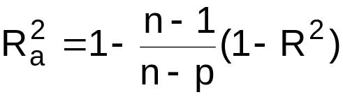
- 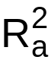 can not be forced to increase as R² can be by adding variables.
- adjusts for having “nonsense” variables (additional variables that do a poor job of estimating Y) added to the model that make R² increase.
- USE INSTEAD OF R²
- The interpretation of is about the same as R²
- ≤ R²
- can be less than 0 (does not occur often)

Example: NBA guard example (nba_example.R)

Examine what happens to R² and 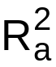 when additional variables are added to the model:

> mod.fit1<-lm(formula = PPM ~ MPG, data = nba)
> sum.fit1<-summary(mod.fit1)
> mod.fit2<-lm(formula = PPM ~ MPG + height, data = nba)
> sum.fit2<-summary(mod.fit2)
> R.sq.values<-data.frame(model = c("MPG", "MPG, height",
"MPG, height, FTP"),
R.sq = c(sum.fit1$r.squared, sum.fit2$r.squared,
sum.fit$r.squared),
adj.R.sq = c(sum.fit1$adj.r.squared,
sum.fit2$adj.r.squared, sum.fit$adj.r.squared))

> R.sq.values
model R.sq adj.R.sq
1 MPG 0.1288889 0.1204315
2 MPG, height 0.1756396 0.1594757
3 MPG, height, FTP 0.1774703 0.1530388

Remember that both height and MPG were significantly related to PPM in the model:

= -0.4022 + 0.004033∗MPG + 0.003586∗Height + 0.0005883∗FTP,

but FTP was not. When a variable is added to the model that “may not” be useful, the decreased. Thus, the decrease in after FTP is added to the model suggests that FTP may not be useful in estimating PPM.

Notice that R² increased after each variable was added to the model.

Note:
    - The low of 0.1595 for all models suggests the model may be poor in estimating PPM. There may be more variables that could help estimate PPM and thus increase .
    - Even though is low, we have shown there is a linear relationship between PPM and height & MPG. Again, more variables would be helpful in the estimation of PPM.

6.7 Estimation of mean response and prediction of new observation

Interval estimation for E(Y_{h}) at X_{h}

Estimate the mean value of Y_{h} for X_{h}=(1, X_{h1}, X_{h2}, …, X_{h,p-1})′

As shown in Section 5.13, the estimated variance used in the C.I. for E(Y_{h}) is


The (1-α)100% C.I. for E(Y_{h}) is
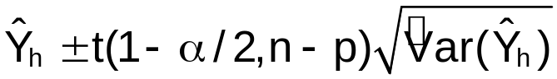

Notice the degrees of freedom are n-p.

Interval estimation for Y_{h(new)} at X_{h}

As shown in Section 5.13, the estimated variance used in the P.I. for Y_{h(new)} is

The (1-α)100% P.I. for Y_{h(new)} is
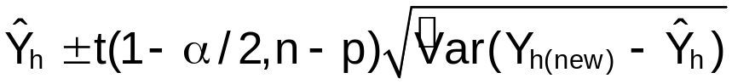

Notice the degrees of freedom are n-p.

If g different C.I.s or P.I.s were desired with a family confidence coefficient of at least (1-α)100%, the 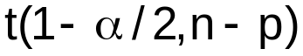 part of the intervals would change to 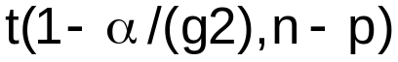. This is an application of the Bonferroni procedure.

Example: NBA guard example (nba_example.R)

Estimate the PPM of a guard who plays 36.0244 minutes per game (on average), is 201cm (6 foot 7 inches) tall, and has a 88% free throw percentage. These are Reggie Miller’s numbers for the 1992-3 season. Use the E(PPM)=β₀ + β₁MPG + β₂Height + β₃FTP model.


 = -0.4022 + 0.004033∗36.0244 + 0.003586∗201 + 0.0005883∗88 = 0.5156

Miller had a PPM=0.5885

Translating this to points per game (PPG):

 = * # of minutes play per game = 0.5156∗36.0244 = 18.57

PPG = 0.5885*36.0244 = 21.20

For Reggie Miller’s data values, find a 95% C.I. and P.I.

 | Estimate | Miller | Lower | Upper
C.I. for E(PPM) | 0.52 | 0.59 | 0.47 | 0.56
P.I. for PPM | 0.52 | 0.59 | 0.30 | 0.73

 | Estimate | Miller | Lower | Upper
C.I. for E(PPG) | 18.57 | 21.20 | 16.84 | 20.31
P.I. for PPG | 18.57 | 21.20 | 10.78 | 26.39

R code and output:

> miller<-nba[nba$last.name == "Miller",]
> save.ci<-predict(object = mod.fit, newdata = miller,
se.fit = TRUE, interval = "confidence", level =
0.95)
> save.ci
$fit
fit lwr upr
[1,] 0.515622 0.4673468 0.5638972

$se.fit
[1] 0.02433555

$df
[1] 101

$residual.scale
[1] 0.1066519

> save.pi<-predict(object = mod.fit, newdata = miller,
interval = "prediction", level = 0.95)
> save.pi
fit lwr upr
[1,] 0.515622 0.2986155 0.7326284

> #PPG
> save.ci$fit*miller$MPG
fit lwr upr
[1,] 18.57497 16.83589 20.31406
> save.pi*miller$MPG
fit lwr upr
[1,] 18.57497 10.75745 26.3925

Interpretation

With 95% confidence, the average PPG is between 16.84 and 20.31 for a guard that plays 36.0244 minutes per game (on average), is 201cm (6 foot 7 inches) tall, and has a 88% free throw percentage.

With 95% confidence, the PPG of a guard is between 10.78 and 26.39 for someone who with plays 36.0244 minutes per game (on average), is 201cm (6 foot 7 inches) tall, and has a 88% free throw percentage.

Since Miller’s PPG is greater than the upper limit of the C.I. for E(PPG), Miller is better (in terms of PPG) than an “average” guard with the same MPG, Height, and FTP.

6.8 Diagnostics and remedial measures

All residual analysis procedures done in Chapter 3 can be done for multiple regression.

Notes:
- To check the linearity of the regression function, plots of e_{i} vs. X_{ij} should be done for j=1,…,p-1 (i.e., plots for each predictor variable).
- The plot of e_{i} vs.  and e_{i} vs. X_{ij} no longer gives the same information (see Section 3.3).
- More diagnostic procedures are discussed in Chapters 10 and 11.

I have generalized examine.mod.simple.R to allow for multiple predictor variables. Please see the examine.mod.multiple.R function on your own!

A scatter plot matrix is a matrix of scatter plots showing the relationship between pairs of variables.

This is often an initial tool used to identify which predictor variables are correlated to the response variable. In addition, this plot helps identify predictor variables that have a strong correlation with each other.

How could the presence of two very highly correlated variables hurt a regression model?

Example: NBA guard example (nba_example.R)

= -0.4022 + 0.004033∗MPG + 0.003586∗Height +
0.0005883∗FTP

> save.it<-examine.mod.multiple(mod.fit.obj = mod.fit,
const.var.test = TRUE, boxcox.find = TRUE)
$sum.data
Y MPG height FTP
Min. :0.1593 Min. : 4.35 Min. :160.0 Min. :37.50
1st Qu.:0.3326 1st Qu.:17.00 1st Qu.:185.0 1st Qu.:74.20
Median :0.4187 Median :24.28 Median :191.0 Median :79.30
Mean :0.4236 Mean :24.30 Mean :190.2 Mean :77.86
3rd Qu.:0.4866 3rd Qu.:33.54 3rd Qu.:196.0 3rd Qu.:84.00
Max. :0.8291 Max. :40.71 Max. :210.0 Max. :94.80

$semi.stud.resid
1 2 3 4 5 6 7 8 9 10
1.07 -0.22 -0.15 0.08 -1.29 -0.44 -1.89 0.71 -0.21 0.74

EDITED

102 103 104 105
-0.14 -0.33 0.71 -1.65

$levene
[,1] [,2] [,3]
[1,] 1 3.6851 0.05766906
[2,] 2 2.7719 0.09896970
[3,] 3 1.5320 0.21863250

$bp
Breusch-Pagan test
data: mod.fit.obj
BP = 27.044, df = 3, p-value = 5.764e-06

$lambda.hat
[1] 0.31
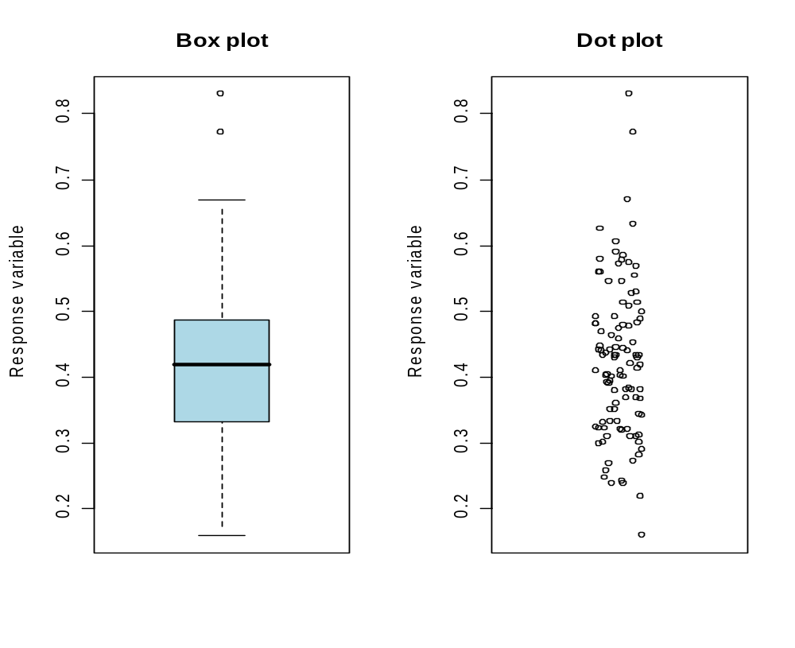
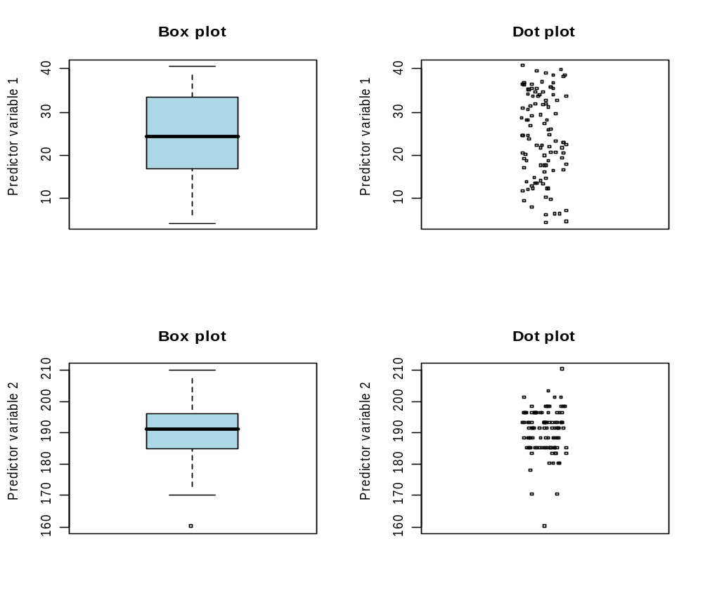

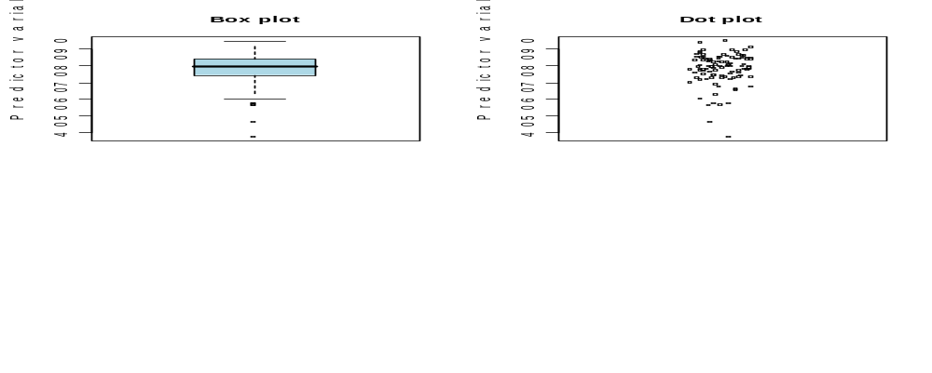

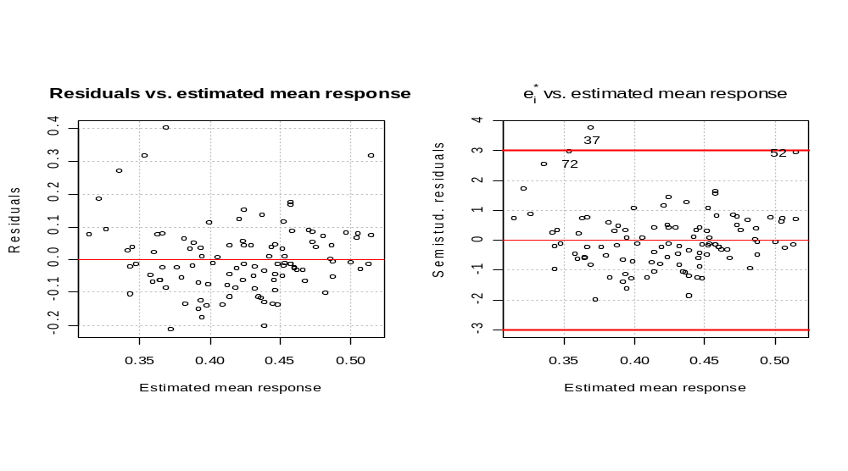
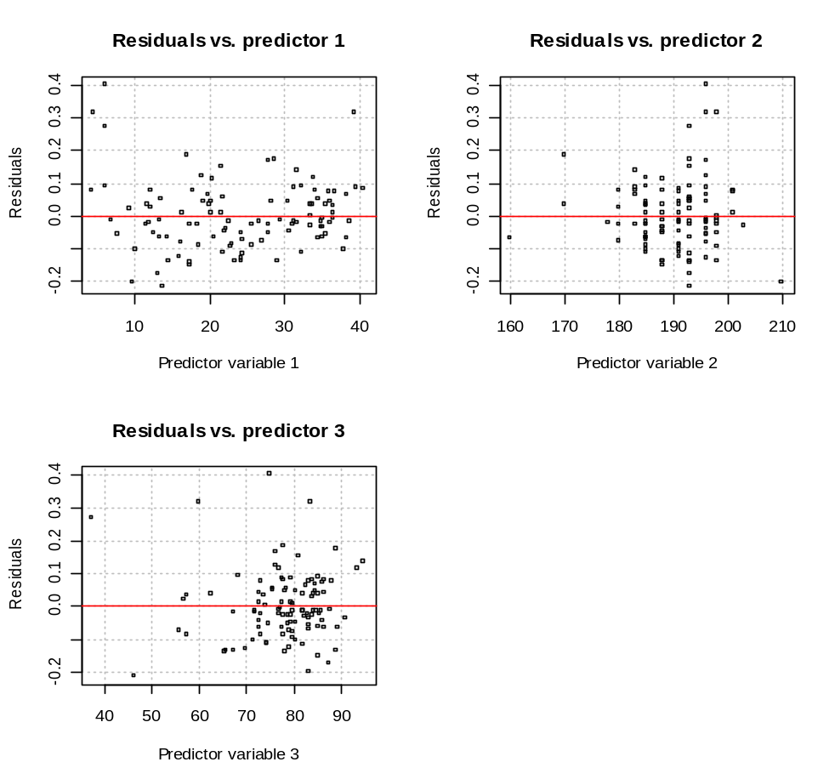
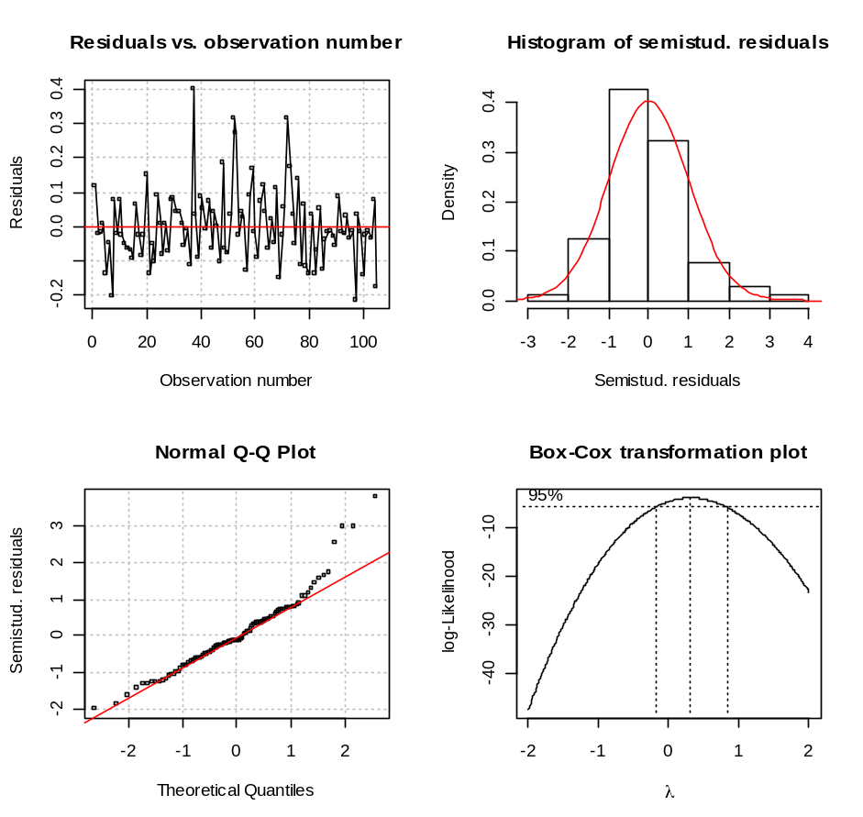

- Diagnostics for predictor and response variables

There are a few outlying values for the PPM, Height, and FTP. Based upon my basketball knowledge though, they are not so outlying that would make me believe there was a data entry error or that they were extremely unusual.

- Linearity of the regression model

Examine the plots of e_{i} vs. X_{ij} for j = 1, 2, 3. Some transformations could be investigated. For example, perhaps a MPG² might be helpful.

- Constant error variance

Examine the plot of e_{i} vs. . There “possibly” is a small problem in this plot because there are not any large in absolute value residuals toward the very low and very high estimated mean responses ends (this is probably too picky!). The Breusch-Pagan test and possibly the Levene tests indicate potential problems with the constant variance assumption.

- Independence of ε_{i}

Examine a plot of e_{i} vs. order of the observation. Since the observations were put in alphabetical order here, the order of the observation does not give meaningful information. If it did, we would say the points appear to be randomly scattered in the plot implying that the ε_{i} do not appear to be dependent.

- Outliers

Examine a plot of  vs. with reference lines at =–3 and =3. There is an observation past this borderline:

> nba[37,]
last.name first.initial games PPM MPG height FTP FGP age
37 Green S. 13 0.7704 6.2308 196 75 50.9 23

There are a few others that are close.

- Normality of ε_{i}

Examine the histogram and QQ-plot of . Both plots indicate a potential deviation on the right side of the distribution. This is because the points on the QQ-plot tend to deviate from the straight line for the larger positive values and the shape of the histogram is a little right-skewed.

- Additional predictor variables

I will do this in a later investigation of this model after we go through some more chapters.

Chapters 10-11 will give us more tools to better evaluate the model. Further discussion of how to fix the potential problems here will be deferred to until then.

> pairs(~age+FGP+FTP+height+MPG+PPM, data = nba)
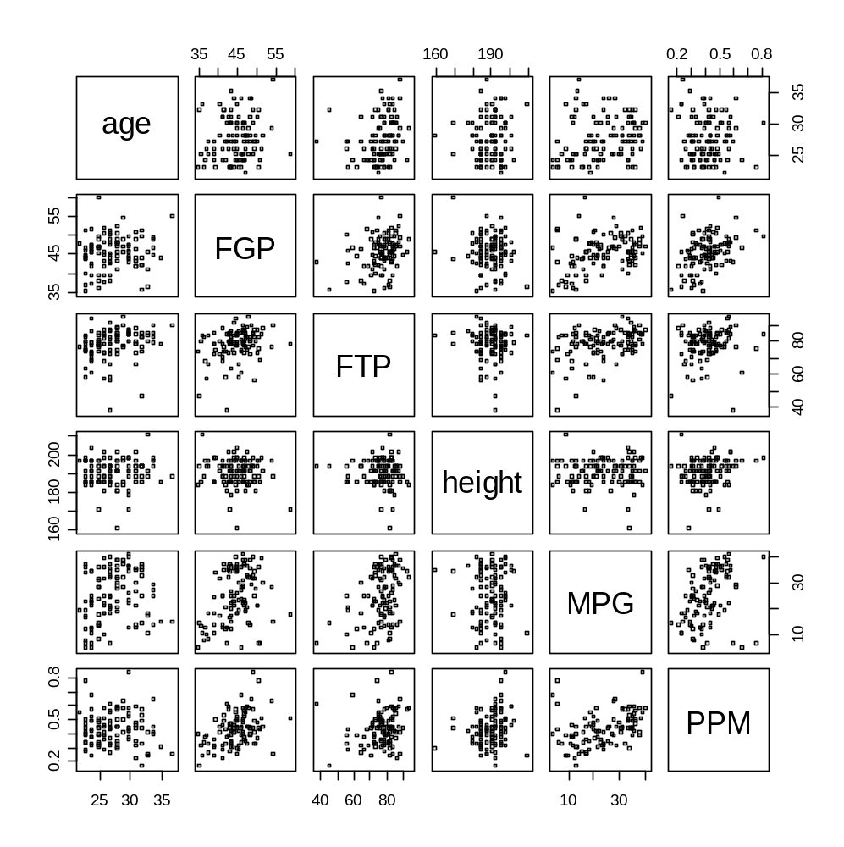

Note that

pairs(formula = PPM~age+FGP+FTP+height+MPG, data = nba)

also works.

See the help for pairs() for how to make the previous plot fancier. Alternatively, one can use the scatterplotMatrix() function in R’s car package (for Fox’s book), which already does.

> library(car)
> scatterplotMatrix(x =
~age+FGP+FTP+height+MPG+PPM, data=nba, reg.line=lm,
smooth=TRUE, span=0.5, diagonal = 'histogram')
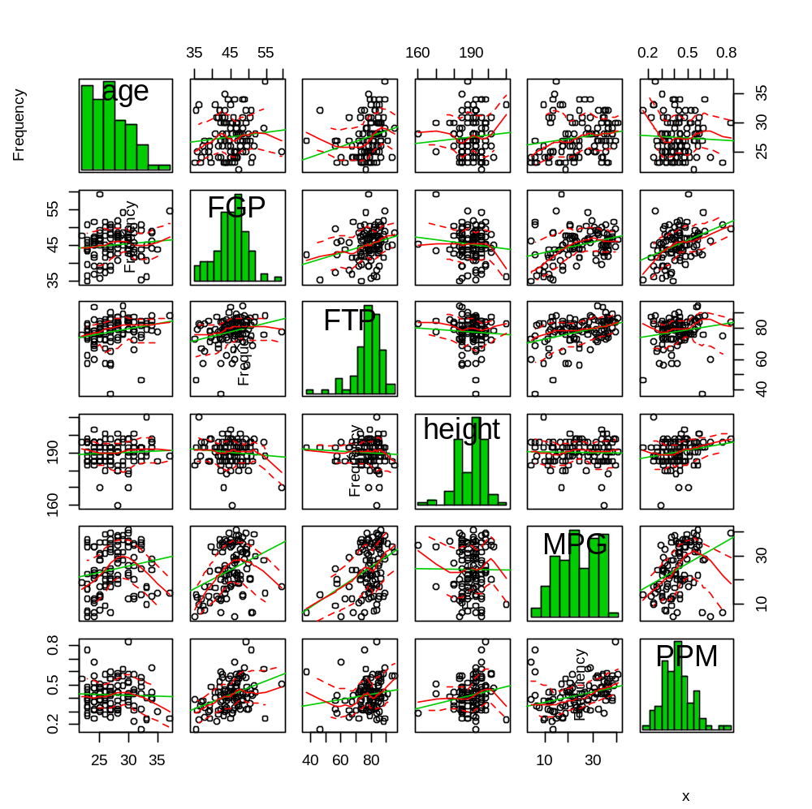

Notes:
    - Histograms are plotted on the diagonal to provide additional information. Other items can be plotted on the diagonal as well (see help for it).
    - A simple linear regression line and a lowess smoother are plotted as the dashed and solid lines, respectively, to help show the relationship between two variables. Lowess smoothers will be discussed in Chapter 11.

The code below allows one to interactively brush points on the plot.

#Allows for brushing points
library(TeachingDemos)
tkBrush(mat = nba[,3:8], hscale=1.75, vscale=1.75)

I had difficulty getting a good screen capture so a picture is not included.

Correlation matrix:

> round(cor(x = nba[,4:8], method = "pearson"),4)
PPM MPG height FTP FGP
PPM 1.0000 0.3590 0.2125 0.1674 0.4063
MPG 0.3590 1.0000 -0.0104 0.3914 0.3396
height 0.2125 -0.0104 1.0000 -0.0613 -0.1081
FTP 0.1674 0.3914 -0.0613 1.0000 0.2786
FGP 0.4063 0.3396 -0.1081 0.2786 1.0000

A final note: Be careful about predicting Y outside the range of your data!

6.9 An example – multiple regression with two predictor variables

Read this example!

